**R Code for Examples in the book**

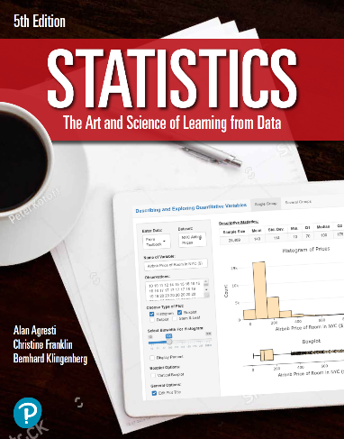

***“Statistics: The Art and Science of Learning from Data”***

**by Agresti, Franklin and Klingenberg, 5th edition**

**Chapter 11**

**Example 6: Mendelian Genetics – Testing Goodness of Fit**

## Reading in data:

observed <- c(6022, 2001)  
expected <- c(0.75, 0.25)

## To perform a chi-squared test for goodness of fit

chisq.test(x = observed, p = expected)

##   
## Chi-squared test for given probabilities  
##   
## data: observed  
## X-squared = 0.014999, df = 1, p-value = 0.9025